**SQL Developer Internship Documentation**

**Window Functions**

**Objective:** Utilize SQL window functions to rank students and perform cumulative analysis.

**Project Steps:**

1. **Dataset Setup**
   * Create and Populate Table:
     + Define a table Students with fields like:
       - StudentID (Primary Key)
       - Name
       - MathScore
       - TotalScore
     + Populate with sample data for the analysis.

**Query:**

CREATE TABLE Students2(

StudentID INT PRIMARY KEY,

Name VARCHAR (50),

MathScore INT,

ScienceScore INT,

EnglishScore INT

);

**Tasks to Perform**

**Task 1: Rank Students Based on Total Scores**

* + **Query Objective:** Use the RANK () function to assign ranks to students based on their TotalScore.
  + **Query Explanation:**
    - Use RANK () OVER (ORDER BY TotalScore DESC) to rank students in descending order of their total scores.
    - If two students have the same score, they receive the same rank, and the next rank is skipped.

**Query:**

SELECT StudentID, Name, MathScore, ScienceScore, EnglishScore,

(MathScore + ScienceScore + EnglishScore) AS TotalScore,

RANK () OVER (ORDER BY (MathScore + ScienceScore + EnglishScore) DESC) AS RankOfStudents

FROM Students2;

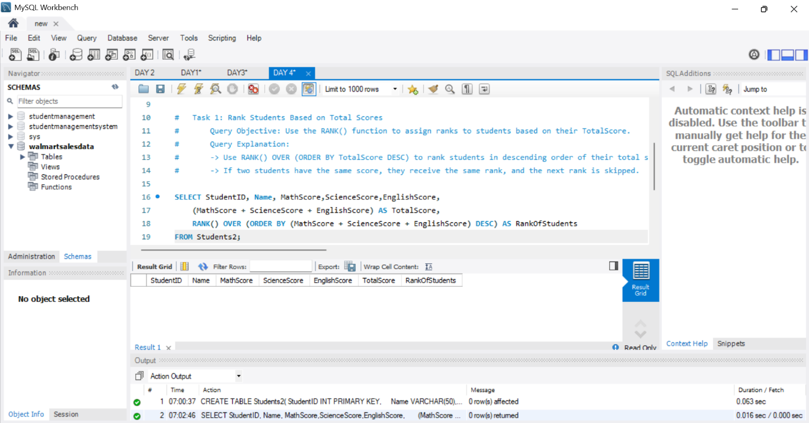

**Task 2: Calculate Running Totals for Math Scores**

* + **Query Objective:** Use the SUM () function with OVER () to calculate running totals of MathScore ordered by StudentID.
  + **Query Explanation:**
    - Use SUM(MathScore) OVER (ORDER BY StudentID) to compute a cumulative total.

**Query:**

SELECT StudentID, Name, MathScore,

SUM(MathScore) OVER (ORDER BY StudentID) AS RunningTotal

FROM Students2;

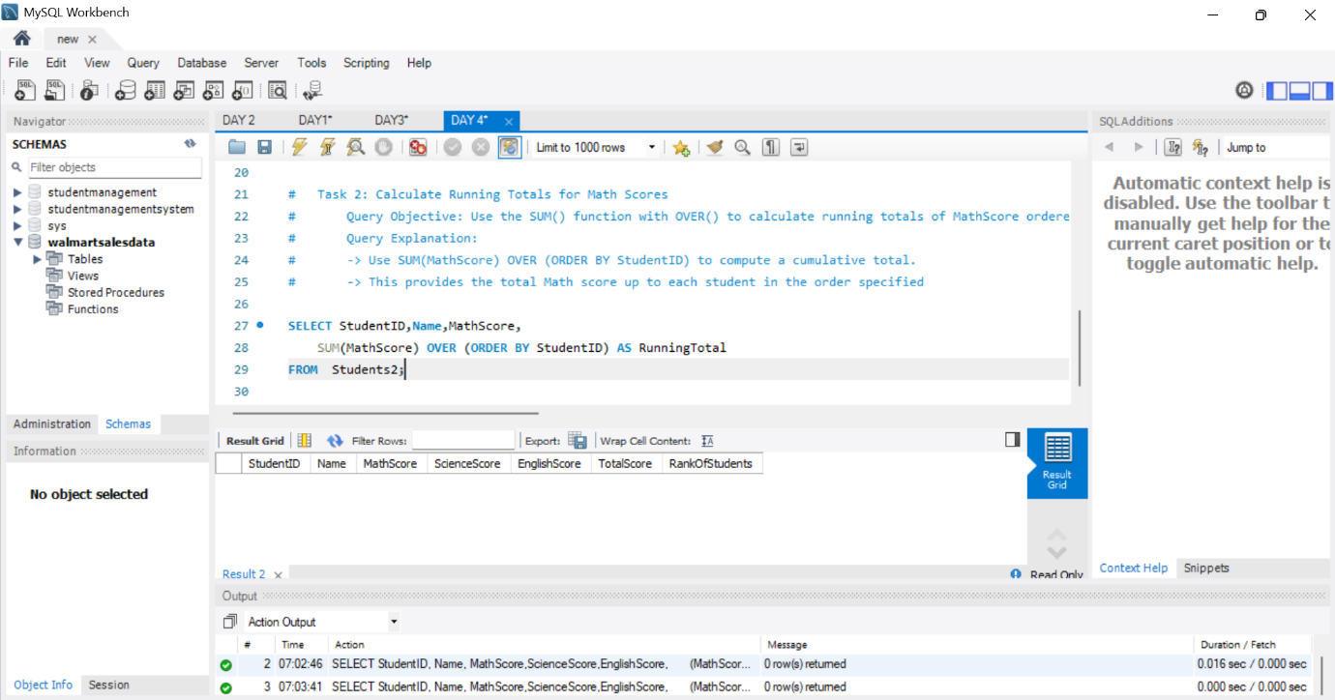

**Summary of Key Findings :**

1. **Top Students by Total Scores:** Identifies top-performing students based on their total scores, highlighting the highest achievers.
2. **Average Performance:** Provides insight into average student performance based on specific conditions, helping to understand trends in student scores.
3. **Second-Highest Scores:** Identifies students who have the second-highest Math scores, showcasing those just below the top performers.
4. **Window Functions Analysis:** Ranks students based on total scores and calculates running totals for Math scores.

**Main Flow Services and Technologies Pvt. Ltd.**

* Contact No.: +91 9389641586, +91 97736 99074
* Email: contact.mainflow@gmail.com
* Website: www.mainflow.in